Justin Cabral

CS 5084

Assignment 1

Stable Matching Problem

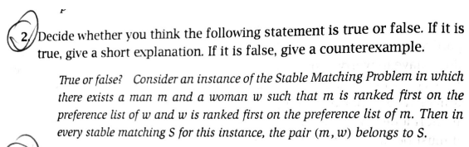

True. Since the pair (m, w) rank each other first on their preference list, any other possible matching result would occur as an unstable match since the pair (m, w) each rank the other first over any prospective partners.

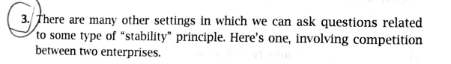

Example:

Suppose Network A has two shows (x, y) with ratings (11, 15)

Suppose Network B has two shows (w, z) with ratings (7, 13)

If the resulting pairs are (x, w) and (y, z) then Network A would win both slots, but Network B would want to switch the order of the shows in its schedule so it could win at least one slot rather than win none.

If Network B changed its line up so the new pairs were (x, z) and (y, w) then each network would win one slot, however network A would just change the line up again so that it won both slots.

Thus, the result is no stable pair of schedules because both networks will continue to restructure their schedules to win more slots.

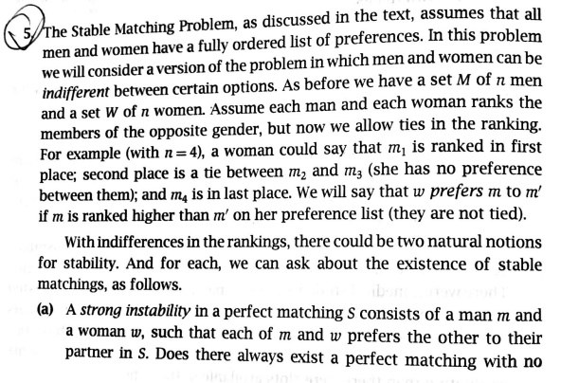

The answer is yes. A straightforward way to accomplish this would be to break the ties and then run the stable matching algorithm on the resulting preference lists. For example, we could assign the indifferent men or women based on the order they appear in the set.

If m were to appear before m’: m = m1 & m’ = m2 then m would be assigned the higher rank on the woman’s preference list.

If m’ were to appear before m: m’ = m1 & m = m2 then m’ would be assigned the higher rank on the woman’s preference list.

This same technique can be done for the women with respect to the men’s preference list as well.

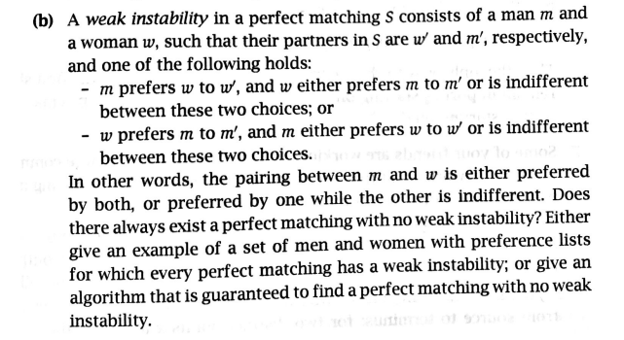

The answer is no. If a man is indifferent between any of the women and both women prefer the same man over the other, it would result in a weak stability.

For example: The men are (m1, m2) and our women are (w1, w2)

Let m1 be indifferent between w1, and w2

Let both women prefer m1 to m2

The choice that m2 would make has no significance. Thus, there is no matching without weak stability, since no matter which women is matched with m1 it would form a weak instability.

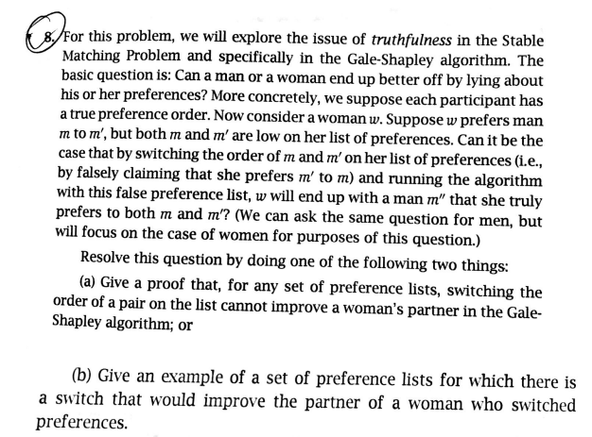

For B:

|  |  |  |  |
| --- | --- | --- | --- |
| Preference List 1 | | | |
| m1 | w1 | w2 | w3 |
| m2 | w2 | w1 | w3 |
| m3 | w1 | w3 | w2 |

|  |  |  |  |
| --- | --- | --- | --- |
| Preference List 2 | | | |
| w1 | m2 | m1 | m3 |
| w2 | m1 | m2 | m3 |
| w3 | m1 | m2 | m3 |

Our resulting pairs = {(m1, w1), (m2, w2), (m3, w3)}

This means that w1 was able to get her second choice.

If we change the table to reflect w1 change in preferences

|  |  |  |  |
| --- | --- | --- | --- |
| W1 changes preference | | | |
| w1' | m2 | m3 | m1 |
| w2 | m1 | m2 | m3 |
| w3 | m1 | m2 | m3 |

Our resulting pairs = {(m1, w2), (m2, w1), (m3, w3)}

This means that w1 got her first choice. Thus, showing she improved the pair she got by switching her preference.